Project 1 Written Analysis

Group Collaborators:

Joshua Steinmetz, Martin Carriel, Scott Stevener

* **How do Missourians commute?**

1. As would be expected, as massive majority of Missourians commute by car (depicted by the census as “Solo Commuters”). A resounding 86% of all Missourians are “Solo Commuters”.
2. The second largest group of commuters are carpoolers and make up 10% of all Missouri commuters.
3. Only 2% of people use the state’s Public Transit and 2% commute by walking.
4. These results were expected as it is widely known that St. Louis which represents Missouri’s most densely populated area does not have a widely used public transit system.
5. It was also interesting to look at concentration of commuters in the form of a visualization with the use of a heatmap utilizing gmaps. There is nothing completely unexpected from the heatmap, but it is interesting to visualize Missouri’s most densely populated areas by way of commuter concentration.

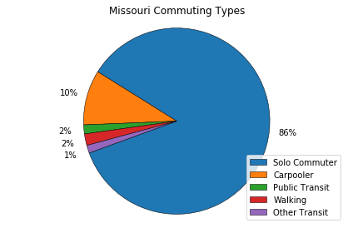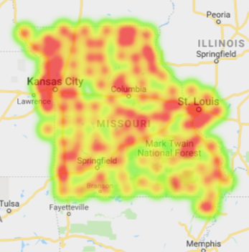

* **What differences exist for commuting types across counties in Missouri?**

1. When comparing counties in Missouri we divided all counties by Rural or Metro, grouped the data by those two variables and put them side by side.
2. Due to the fact that the metro areas as stated before have significantly low amounts of people utilizing public transit, differences were not extremely significant. In both types of counties, a massive majority of people are Solo Commuters.
3. One notable differentiation is that the rural counties do have a significantly larger amount of people who Carpool as a means of commuting as well as people who are walkers. This could be due to the fact people in general live closer to their place of work and a smaller range of potential employers could account for more people riding together to work.

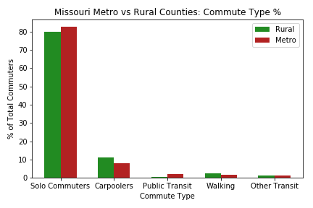

* **What differences exist for commuting types within metropolitan areas in Missouri?**

1. When comparing different counties across Missouri we looked specifically at differences between Kansas City, St. Louis and Springfield. We included all counties which had a corresponding “Metro Pole” for each of the greater metropolitan areas. We compared them by percent of commuters for each commuting type.
2. We found that each of the areas were very similar however we did in fact make a few notable observations which could inspire further inquiry. For instance, Springfield has a larger population of people who commute by walking which also correlates with a larger percentage of commuters who carpool. This could be due to the fact that many people who live in Springfield live or work on or near a college campus.

